 | NEWSLETTER |  |  |  |  | 
 | ISSUE NO 2| september 2025 | |  |  |  |  | STIRLING CURLING GROUP
 | WELCOME to the start of the 2025/26 Curling season. We unfortunately had a blip for our first week with a delay to the ice hall repairs. Our opening bonspiel, the Doune Rosebowl had to be cancelled, but we hope that as many teams as possible will transfer their place to our Closing Bonspiel, the Winnock Shield. For Clubs and Leagues that were impacted by the late opening of the ice, there will be a “spare ice” sheet issued from Active Stirling shortly to help you re-book. SCG are working with the curlers affected in our leagues to get cancelled fixtures re-arranged.  PLEASE KEEP OUR ICE CLEAN  The strict protocols on footwear and cleanliness in the NCA are being reinforced, so please help by cleaning your equipment before entering. We also need to help our ice techs by keeping the main ice hall as clean as possible. Please try and change your shoes in the changing rooms, not alongside the rink. Outdoor shoes bring a lot of debris into the arena and you can minimise this by changing in the rooms provided and only using clean shoes alongside the ice rink. Check your shoes and kippers for wear and tear. |  |  |  |  | We are changing  We our changing our image over the next few months so this is an interim style to get things moving. We welcome your news and ideas for articles in future newsletters. Send in your curling photos too.
Committee
Chair: Mike Gellatly Secy: Marcus Wood Treas: Janet Simpson Ordinary Members: Stephen Walker, Gordon Jackson, Madge Christie, Jacky McLaren and Gill Smith, Craig Kyle, Fraser Sutherland, Moira Foreman and Arran Bauer. Active Stirling Reps: Hammy McMillan and Thomas Mann.
If you are interested in getting involved and helping shape the future of curling in Stirling, please get in touch.

wINNOCK sHIELD
Our annual charity curling event will be held on March 18th 2026. Please support this event and enter a team for one or both of the sessions at 3pm and 6pm using the following link: Winnock shield
MUIRHEAD PAIRS
Entries are now open for our Pairs competition to be held over the weekend 3-4 January 2026. The winners will be presented with the Muirhead Trophy and will represent Stirling at the National Pairs finals. Use the following link to enter: Pairs
INDOOR GRAND MATCH
This is happening on 15 November this year and there are still a few places available. Unfortunately, Stirling is not hosting, so Stirling games will all be away games. Contact Scottish Curling if your club wishes to participate.

COMMUNICATIONS
We have set up a What’s App Communities Group which will allow us to post information to reach as many of our curlers as possible. It is not a chat group but an information noticeboard, so please apply to join as we cannot reach you unless you join. It is a great way of contacting you about last minute changes, for example, If ice is cancelled at short notice, we can let everyone who is a member know. Click here for the link.
We now have a new Facebook page called Curl Stirling where information, stories and photos will be shared. Access it here.
We also have an Instagram page – Curl Stirling where we can post photos and more.
The Website is going to be re-vamped but in the meantime this is still the place you will find league standings and competition results as well as news and competition entry forms.

Sticks and Stones winners 2024/5  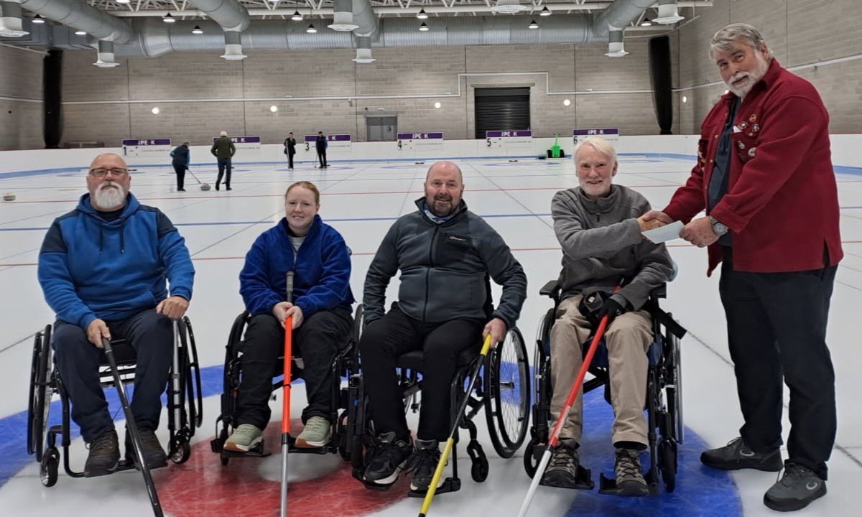  Team McQuade being presented with their prize by committee member Stephen Walker. |  |  |  |  | BLAIR DRUMMOND CC  Annual Quiz Night at Blair Drummond Community Hall  Saturday 18 October 7.30pm  Tea, coffee and cakes or BYOB.  Tickets £6 from Alaina on 07494 432180 or Max on 07774 412156  Maximum team size is 6.
CONTACT DETAILS:
secretarystirlingcurlinggroup@gmail.com chairstirlingcurlinggroup@gmail.com treasurerstirlingcurlinggroup@gmail.com
Stirlingcurlinggroup.org
Facebook
www.stirlingcurlinggroup.org

